What a Reserve Study Is:
A Reserve Study is a long-term financial and physical planning tool used by HOAs to budget for the repair and replacement of major common area components (like roofs, siding, and paving). It identifies the expected lifespan of these assets and lays out a 20- to 30-year funding plan to cover future costs without sudden special assessments.

When: According to Aspen Reserve Study (ARS), a Study should be done every year prior to the budget creation to help establish reserve assessments. CCIOA does not require a Reserve Study.

Why:
Our last Study was done in 2016 and many projects noted within that report had not yet been addressed to date. Given the immense rise in costs to all projects noted, an update was necessary to fund for today’s physical state of the property coupled with the financial picture of the association.

Current financial position:
Last year’s special assessment caught us up from several years of underfunding both the operating and reserve assessments done to alleviate ownership of financial challenges while emerging from COVID, inflation, etc.
Due to the excellent work of our ownership to fund the 2025 special assessment, our reserve account is currently 40% funded according to the 2026 Study’s findings; however, we still have many items on the study requiring immediate and near immediate attention.

Urgent projects per the Study:
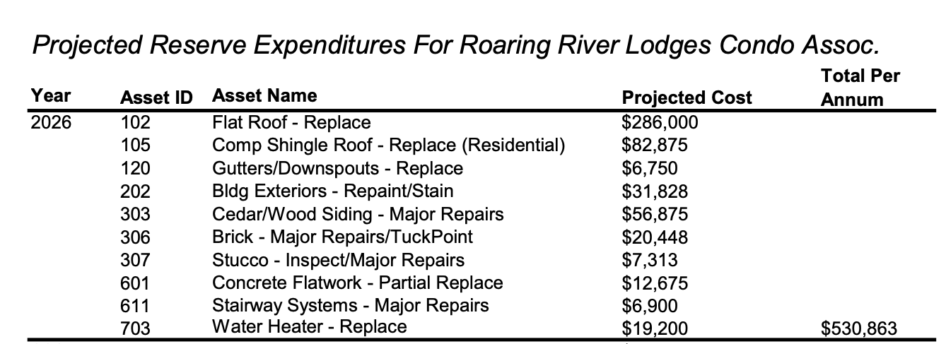

Maintenance Plan (funding dependent):
Upon review of the Reserve Study with our Property Manager, Jason Anderson of Anderson Property Management, who has eight years of familiarity working on our property, we have decided on the following plan of attack to attend to the imminent fixes while addressing other line items along the way to begin trending in the right direction.

- Jason will engage CORE to perform a study to install mini splits throughout the complex for all owners who would like them.
  - This will be an immediate value-add for all properties who take part while we tackle major improvements on the Residential building (Building A). Owners with swamp coolers will be able to immediately abandon their inefficient and maintenance-heavy systems upon mini split installation.
*This will be an individual owner cost separate from the proposed Special Assessment and Reserve Assessment increase, but owners will be eligible for a rebate to recover some of the cost.
- We will engage an architect to work with CORE to plan a siding replacement on Building A, taking mini split condensers and a future roof replacement into consideration.
  - Upgrading from a wood siding to a fireproof siding material will not only be an effective measure in fire mitigation (a MUST in our current climate), but it will also resolve ongoing pest infestation and has the potential to alleviate costs of insurance premiums while improving the overall look of the building.
- Deb has obtained roof estimates to replace the roof of Building A and that project will be slated to begin shortly after or in conjunction with the siding project.
- Jason will begin addressing other time sensitive items on the list, such as brick repairs/tuck point, stucco repairs, and concrete/stairwell repairs to mitigate water/pest intrusion and promote safety on property with this year’s increase in reserve assessments

The above plan will knock out 7 of the 10 items in ARS’ 2026 list, which would be a big win for our association after years of under (or no) funding and capital repairs/replacements.

Funding Options:
A. Recommendation of ARS:
1. $244k Special Assessment with an increase of the Reserve Assessment to each owner of 49%
- This route will fully fund the reserve account per their report and take care of all outstanding projects on the property.

B. Board-Proposed Options:
2. $100k Special Assessment with an increase of the Reserve Assessment to each owner of 10%
3. $100k Special Assessment with an increase of the Reserve Assessment to each owner of 25%
- These options reflect a plan for the Board to take a laddered approach to Reserve projects moving forward; funding, planning for, and tackling one or two major projects every year. We will look at repairs/replacements through the lense of an ‘as needed’ basis.
- Potentially more feasible route for all owners, especially those on fixed income or who don’t foresee a long horizon of ownership at RRL.

